I-ROCK Test Data Summary Report

Category: Sound Analysis & Testing

Test Preformed: ASTM E90 / NIST -accredited

Test Results See Graph Below:

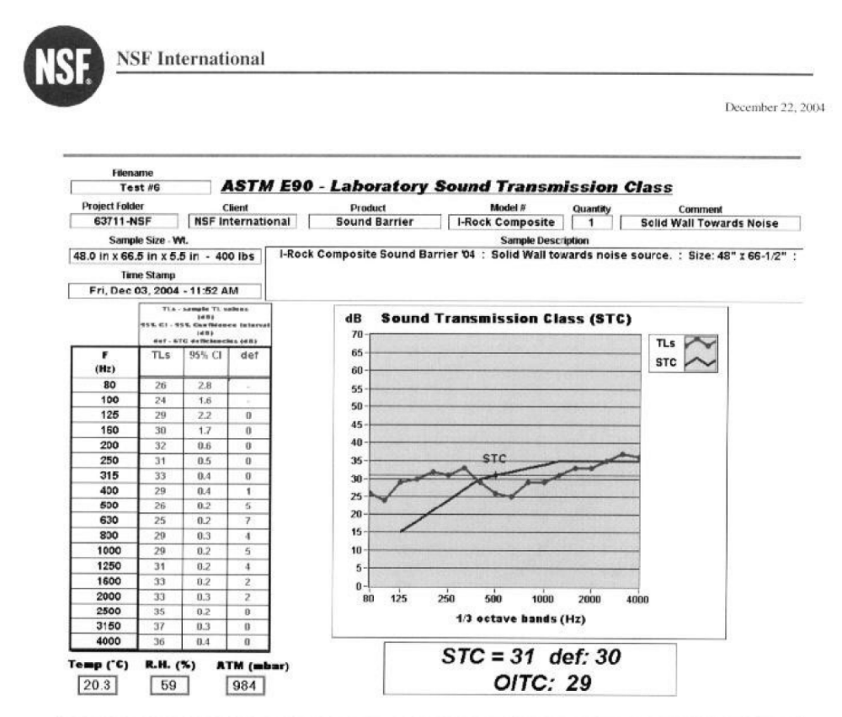

Test Preformed By: NSF International

